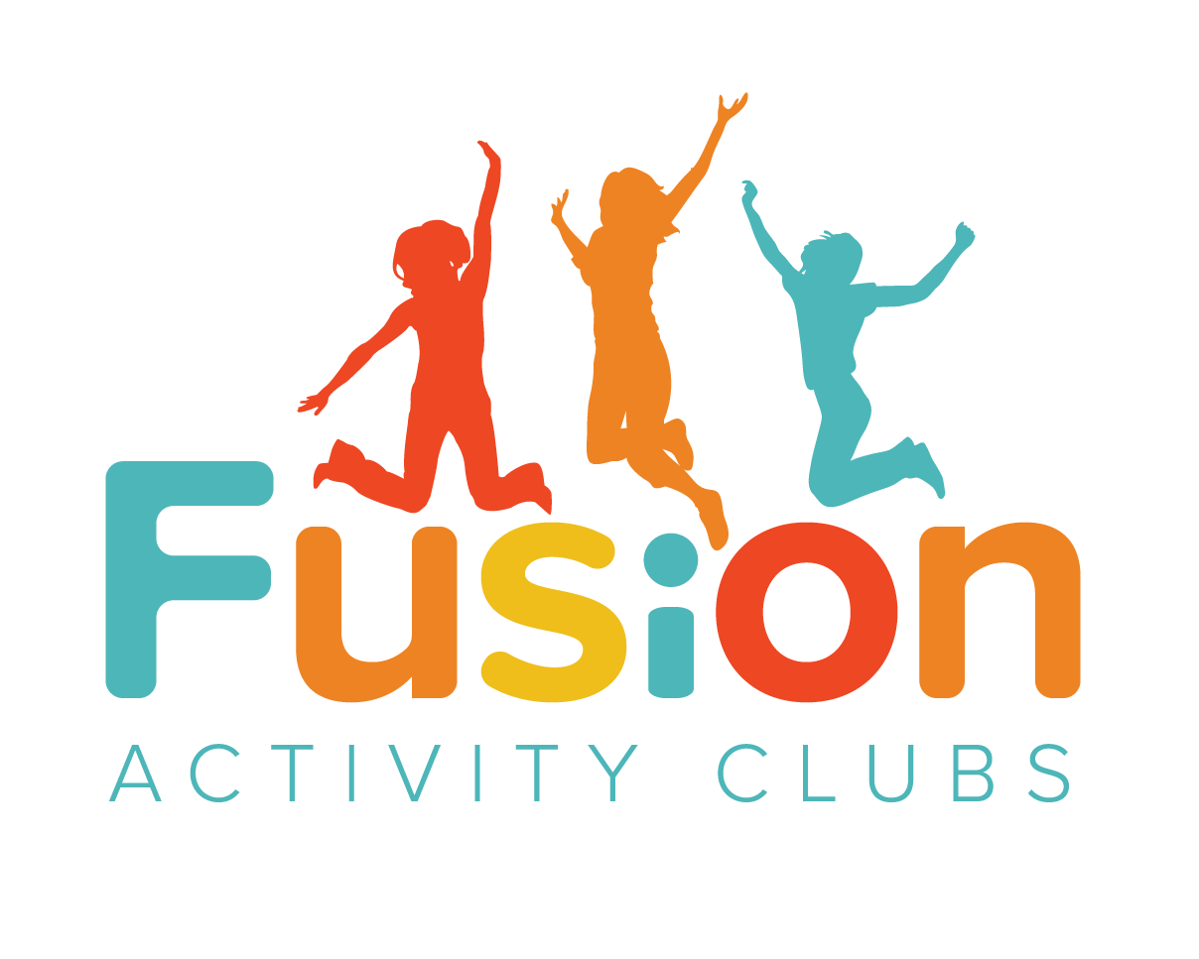

February 2021 Timetable
Day | Morning Activity | Afternoon Activity
Monday | Team Building  Socially Distanced Games  Sport: Mini Golf | Science: Egg Drop Challenge
Tuesday | Craft: Soap Making | Cooking: Strawberry & Banana Cake Bars
Wednesday | Craft: Make your own Crayons | Bingo & Film Afternoon
Thursday | Cooking: Duffins | Sport: Bowling
Friday | Science: Ice Investigation  Craft: Stick Puppets | Party Afternoon

